Exhibitor: How to use the virtual platform

I'm an Exhibitor, what do I do?
The Exhibit Hall area can be accessed anytime the virtual platform is open. This does not mean you are required to be present at your booth the entire time. You are ONLY REQUIRED to be “manning” your booth during the dedicated Exhibit Hall times of Tuesday, September 15 from 10 AM – 1 PM MDT and Wednesday, September 16 from 9 AM – 11 AM MDT.

Once you have been added to the platform (by NEAFCS staff), check your inbox for an email inviting you to join the event (from Accelevents). From that email, click the attached link to head over to the event page.

Note: Chrome is the preferred browser to access the event page, virtual event hub and backstage studio link.

Exhibitors will receive access to the event hub as complimentary registered attendees.

Accessing the Exhibitor Portal
Once receiving access to the event via email, click the Access the Event button found in your email to finish signing up & setting your password. If you do NOT have a password yet, click the "Forgot Password?" option. This will send you an email that allows you to set your own password.

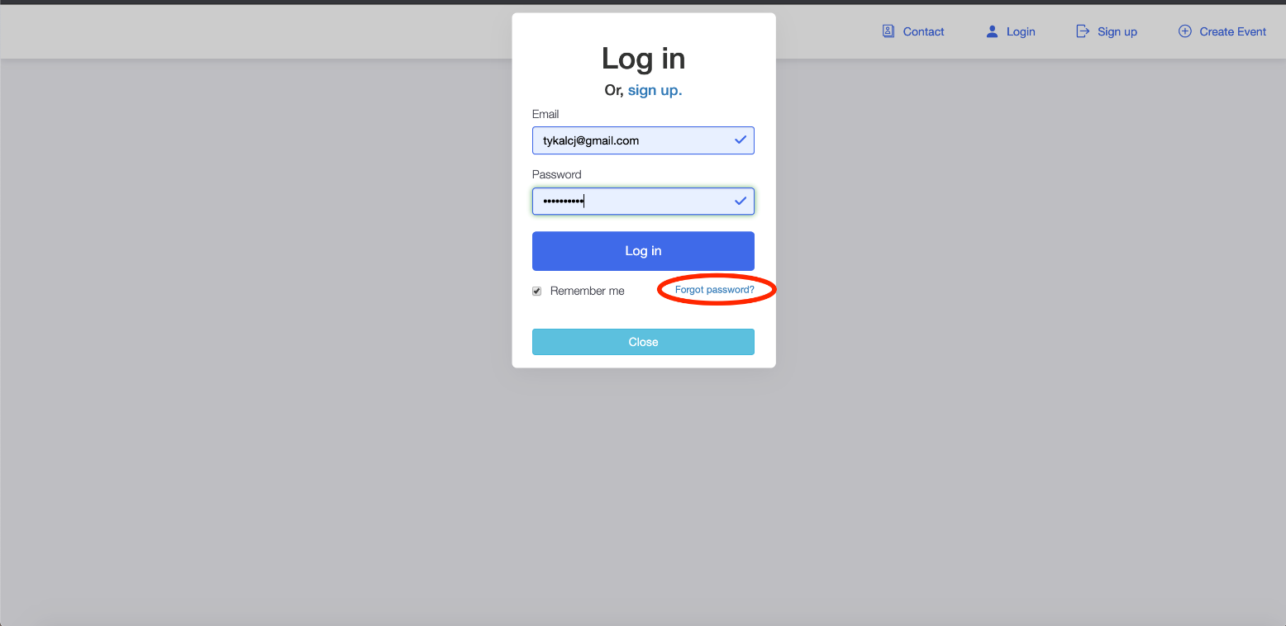
Once logged into your account, click your name in the upper right-hand corner to access the drop down menu & from there, choose the “Exhibitor Portal” option.
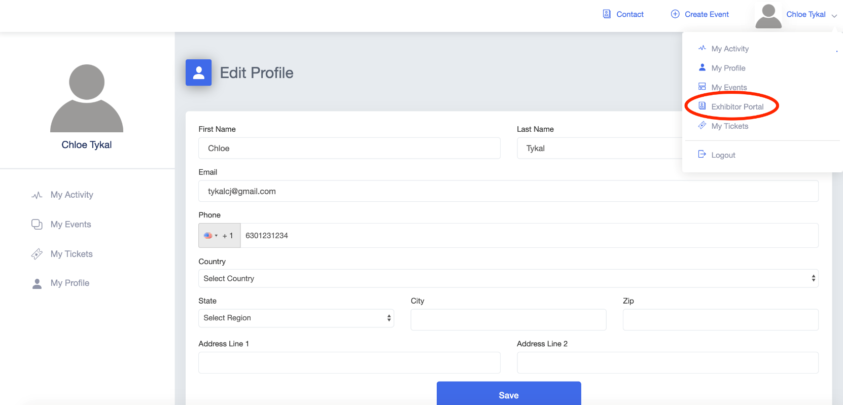

Updating your Vendor Booth Information
Once in the Exhibitor Portal, click on the “Set Up” page

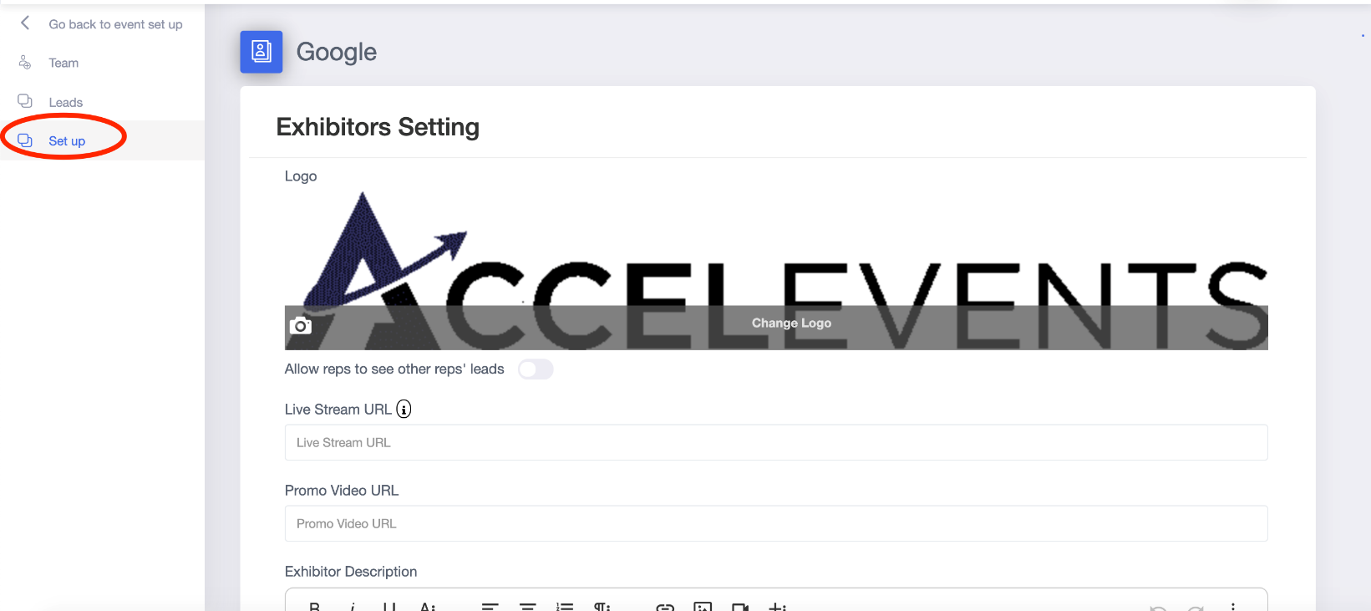

Add any of the following options to your booth:

Logo: We suggest a 700x350 pixel image for optimal fit. The required file formats are PNG or JPG.
Live Stream URL: Add the link to your Zoom meeting. If you purchased the Accelevent Streaming, additional information will be shared soon on how to connect using this platform.
Promo Video URL: Share a pre-recorded video with attendees visiting your booth. Common options are a company overview, a product demo, or a recording of a previously hosted live session.
Exhibitor Description: Add a description of your company/organization. Who are you? What do you provide?
Offer & Offer Link: In the Offer area, add a special deal, discount, or reward for booth visitors. A common option here would be a discount on a product or service for event attendees.
Social Links: Include links to your social media so that interested attendees can stay up to date with your organization.
Documents Available to Attendees: This is the area where you can provide any resources for attendees visiting your booth to view & download. Files here must be a PDF, DOC, DOCX, or DOCXX format. File size can be up to 10mb and up to 20 files per exhibitor.
Click “Save” to save your changes

Lead Generation
Once on your Exhibitor Portal click “Leads”
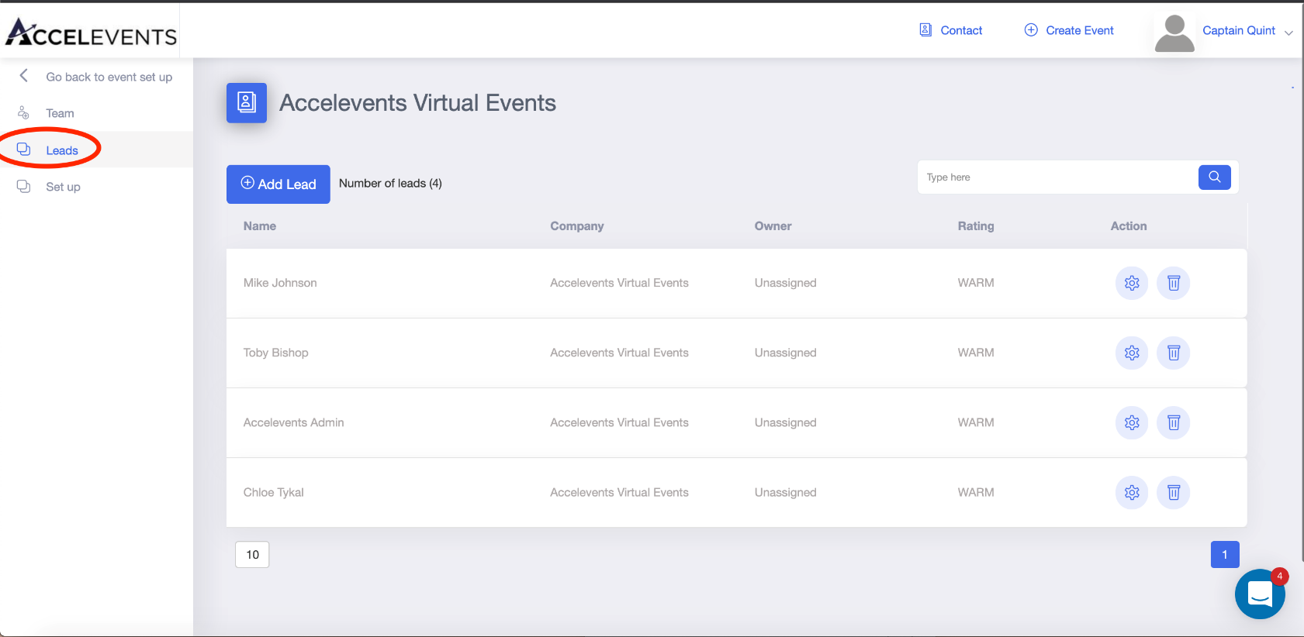
Manually add a new lead by clicking the “Add Lead” button & entering any information you gathered.
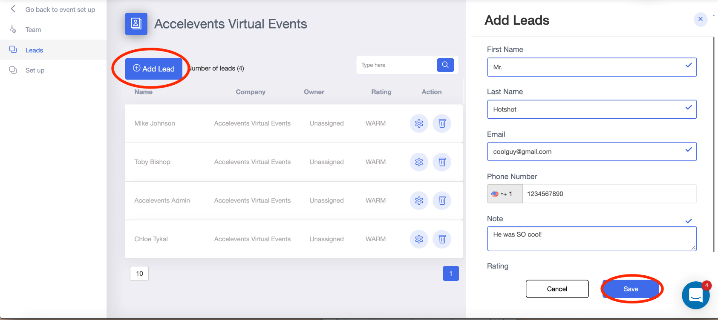
*NOTE* Leads will be automatically entered if an attendee engages with your booth by having a conversation with one of your Lead Retrievers.

Add Staff/Lead Retrievers
- Enter the Exhibitor Portal & click on the “Team” page
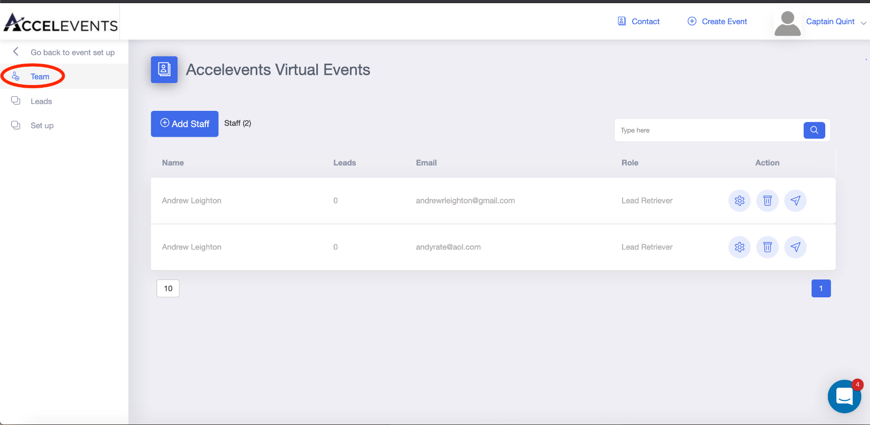
Click “Add Staff” to add a new member to your exhibitor team & enter your teammates information.

Exhibitor Admins: will have access to the Exhibitor Portal to set up & edit booth details.
Lead Retrievers: act as company representatives for the attendees & are available to live chat from within the booth. They will not have access to the Exhibitor Portal & will NOT be able to update/change booth details.

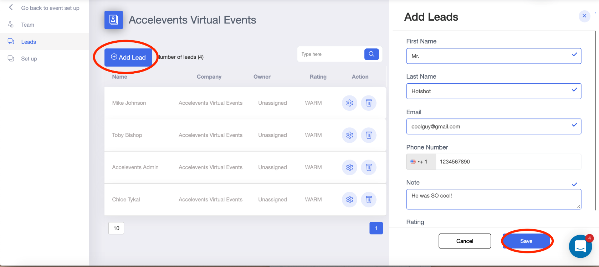
Click “Save” to finalize adding the team member. This will send them an email welcoming them to the booth's staff.

Chat with a Lead
- Enter the virtual event hub from the event landing page.
- Click the Expo area & find your booth.
- Once there, it will mark you as available.
- If an attendee sends a message to begin a conversation with you, it will appear in the right hand chat bar.

Host a Live Demo/Session
*Exhibitor live-streaming needs to be hosted on an OUTSIDE platform (Zoom is the only live streaming platform currently supported.) If you purchased the Accelevent Streaming Service, we will share more information on how to connect to this platform soon.
- Enter the URL to your stream on the Exhibitor Portal → Set Up page
- When ready, begin broadcasting your live session on your chosen platform.
- The stream will automatically be pushed to begin in your booth

Live Stream Set Up
- Once in the Exhibitor Portal, click on the Set Up tab
- Add your Zoom meeting link to the Live Stream URL field
- Make sure to provide your Zoom password to your attendees, you can add that to your description area or provide it through the chat area in the virtual event hub
- Start your Zoom meeting through your Zoom app. Your Zoom stream will automatically begin in your booth.

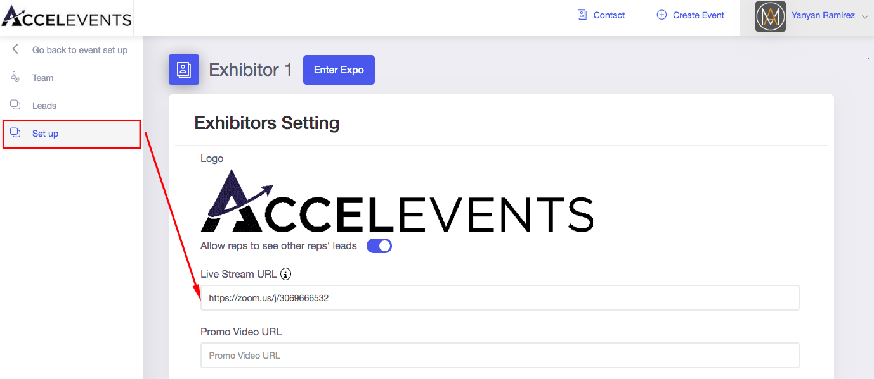

Enter the Expo
- To see how your exhibitor booth would look like, click Enter Expo
- Click the right arrow on your booth to enter your booth
- On the live tab, you should see the option for attendees to join your Zoom meeting
- Attendees will need to enter their name and click Join
- On your end, you should see a request to join the meeting from your Zoom app. Click that to add the attendee to your meeting
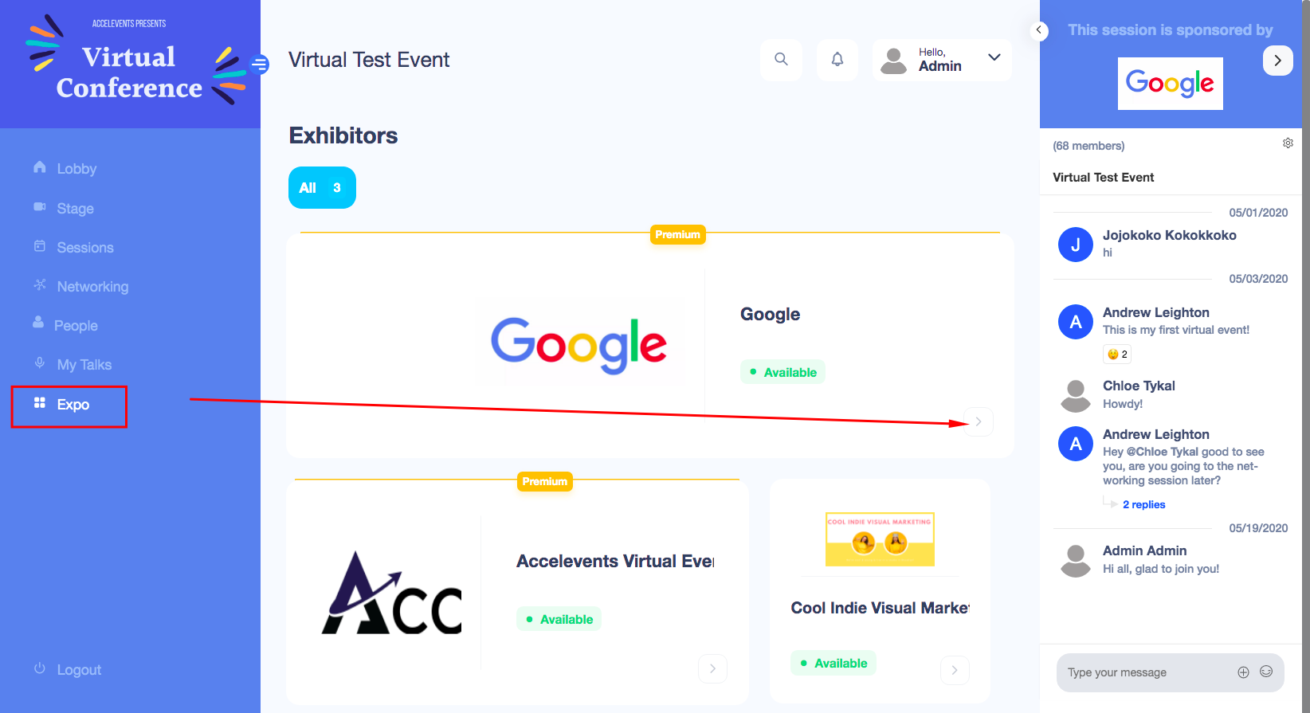

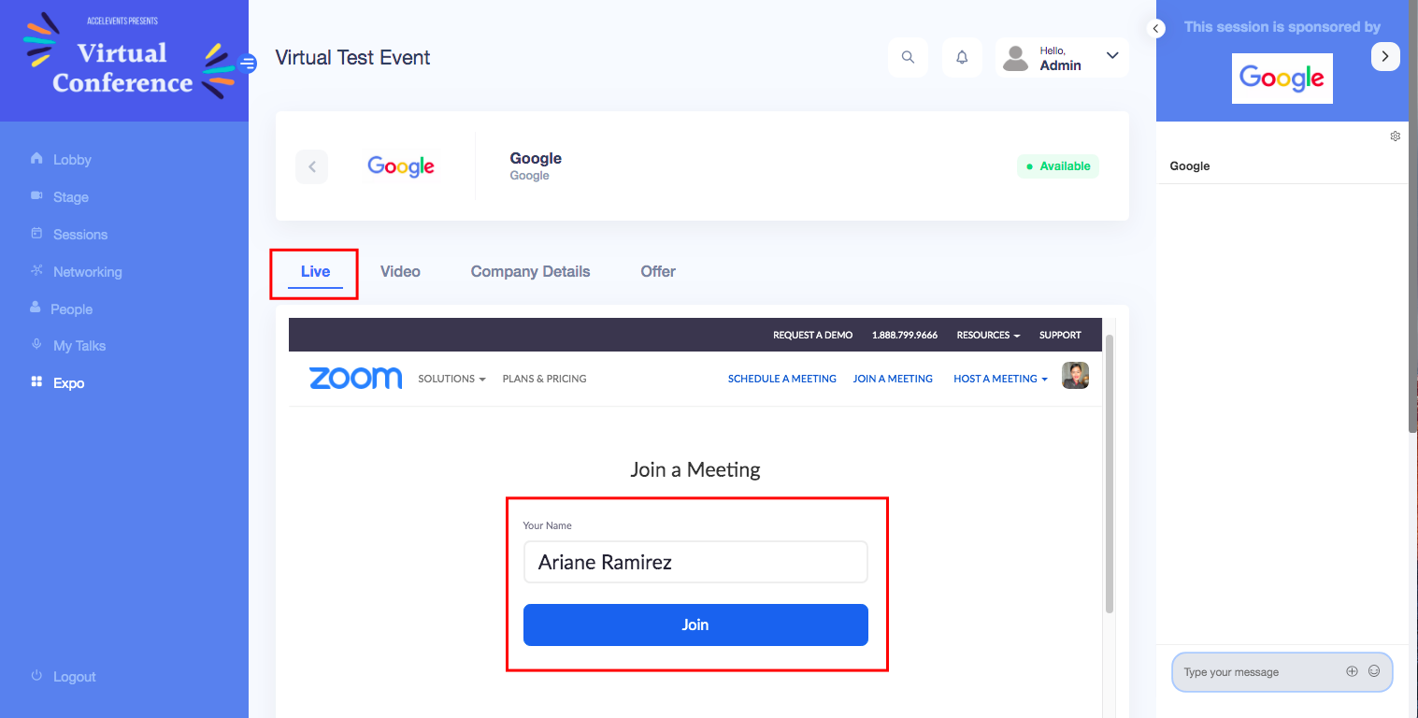

Add Downloadable Content
When you're setting up your booth, you can add downloadable files for attendees. If an attendee enters your booth and downloads that file, the attendee is added as a lead. Make sure to label your file names appropriately so that they will be enticed to click it!
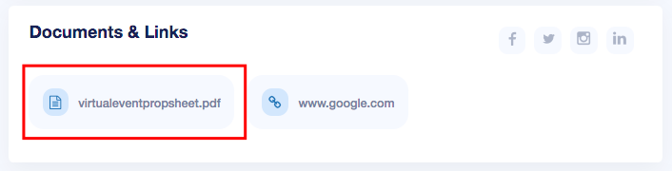

Add a Meeting Option
In your booth, you should see a Request a Meeting button, if an attendee clicks that, they will be added to your lead list. If your button is not in the booth, you may request for your event organizer to enable it.
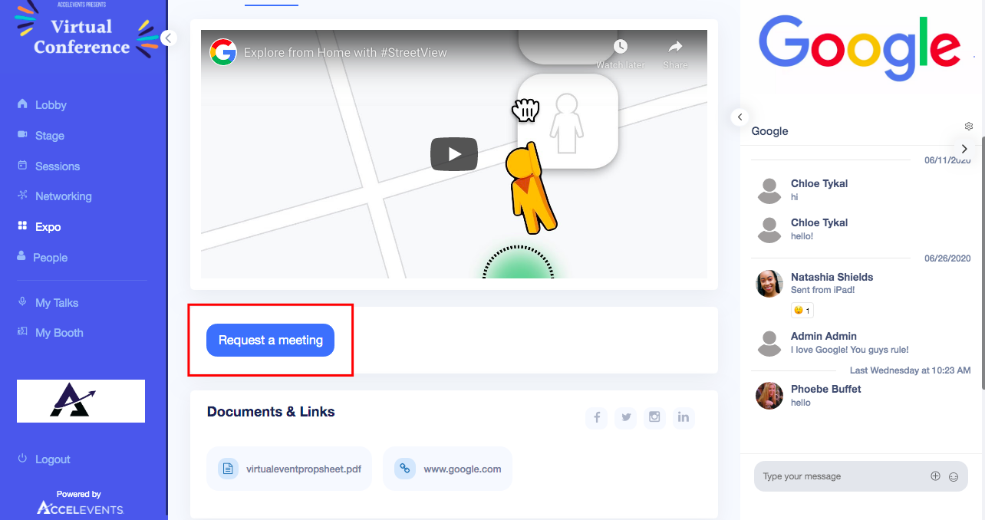

Add a Live Stream
Attendees can join your live meeting through the Live tab in your booth. From that meeting, you may ask for their contact information and add them to your lead list.

Connect Through the People Page
Aside from hanging around in your booth, you can also explore the People Page wherein you can see all the attendee profiles. You may try to connect with them by sending a message or requesting a meeting. It's important that you introduce yourself as an exhibitor so that they can decide whether to accept or decline the connection request.

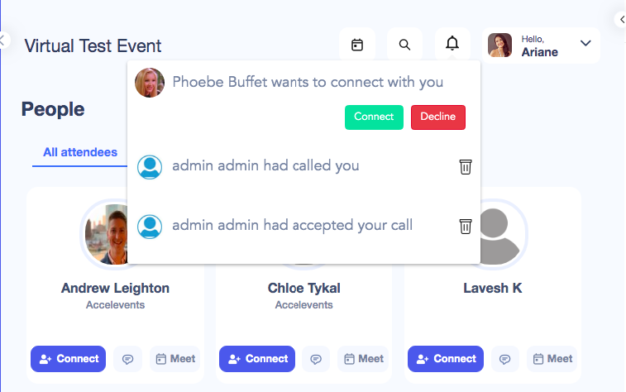
The connections you've made through the People Page will not be added to your leads page, because you are connecting as attendee and attendee instead of attendee and exhibitor. You can add them manually to your lead list if they give you their contact information.

Note: To be able to connect with an attendee, you also need to register as an attendee. All Exhibitors will receive access to the event hub as complimentary registered attendees.

Where can I find my leads?
Exhibitor Portal
In your exhibitor portal, you should see a Leads tab where the leads are listed down with an option to download.

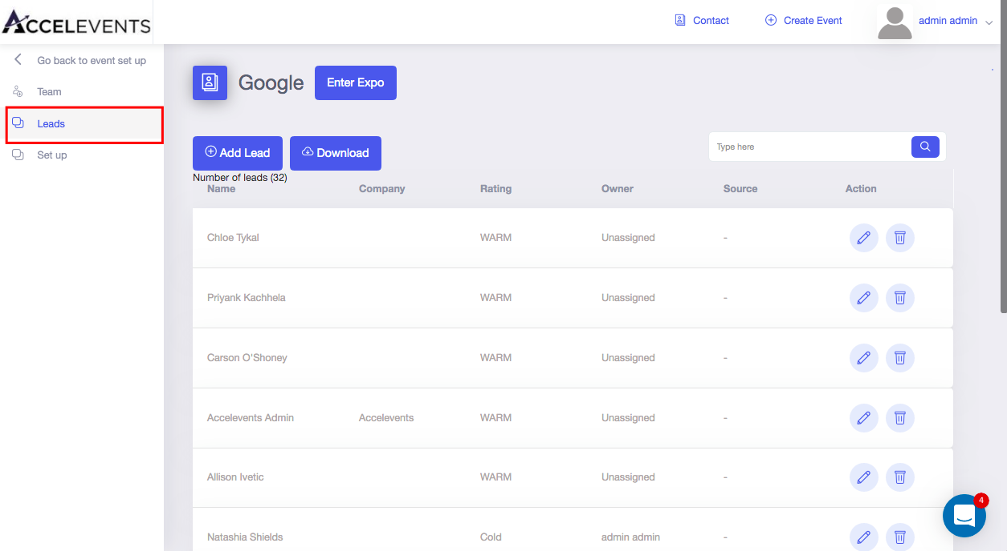
My Booth
In the virtual event hub, you should see a My Booth tab where the leads are listed down with an option to download.

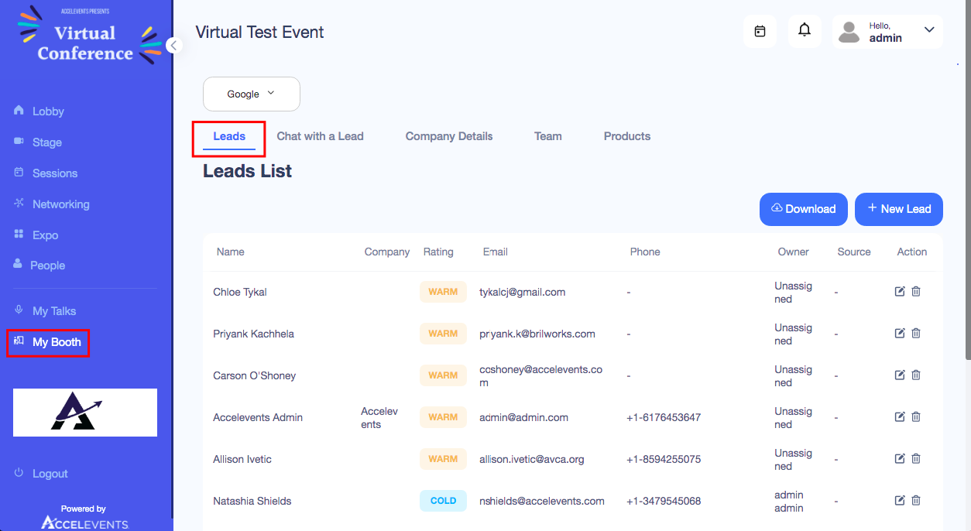

What's the difference of a "Warm" and "Unrated" lead?
Initially, these are the lead ratings that you will see in your Lead tab, but you can change the ratings to Hot, Warm or Cold.
A warm lead is someone who has sent a direct message to your staff or someone who has requested a meeting through your booth.
An unrated lead is someone who has sent a message through your general chat area or someone who has downloaded a file from your booth.

