Speaker: How to use the virtual platform

I'm a Showcase of Excellence (Poster) presenter, what do I do?
Once you have been added to a session as a speaker (by NEAFCS staff), check your inbox for an email inviting you to join the event (from Accelevents). From that email, click the attached link to head over to the event page.
IMPORTANT – Posters will be staged within the Exhibit Hall. You may see email notifications and other headers titled Exhibit Hall or My Booth, that is correct. Although you are being setup as an Exhibitor Booth, you will have the capabilities to presenter your Poster Presentation, provide handouts, etc.
Poster presentations will be accessible via the Exhibit Hall area within the virtual platform. The Exhibit Hall area can be accessed anytime the virtual platform is open. This does not mean you are required to be present at your poster the entire time. You are ONLY REQUIRED to be “manning” your poster presentation during the dedicated poster time of Tuesday, September 15 from 11 AM – 1 PM MDT.

Note: Chrome is the preferred browser to access the event page, virtual event hub and backstage studio link.

Accessing the Exhibitor Portal
Once receiving access to the event via email, click the Access the Event button found in your email to finish signing up & setting your password. If you do NOT have a password yet, click the "Forgot Password?" option. This will send you an email that allows you to set your own password.

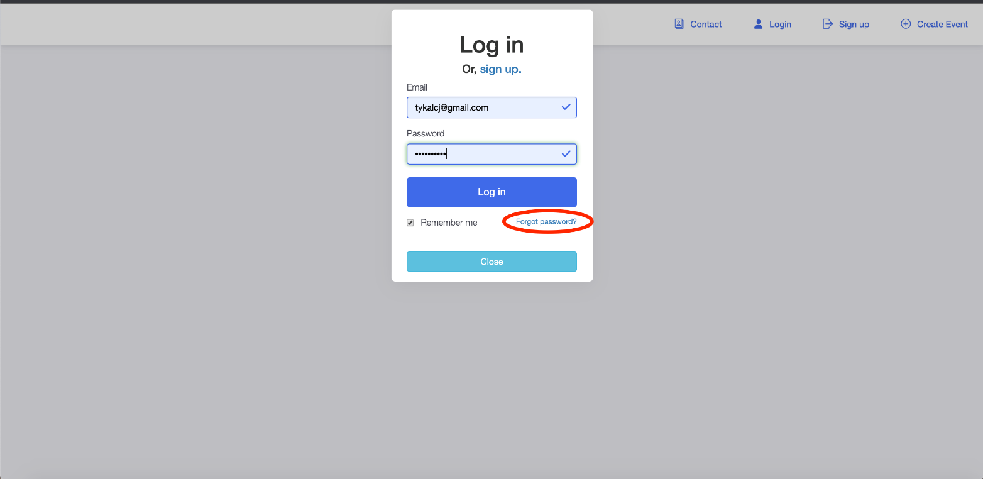
Once logged into your account, click your name in the upper right-hand corner to access the drop down menu & from there, choose the “Exhibitor Portal” option.
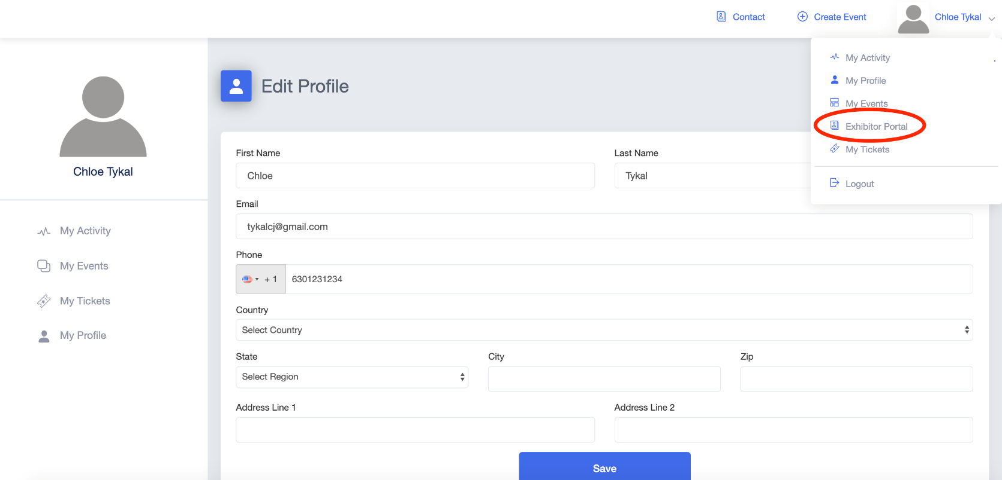

Updating your Information

Note: NEAFCS has already uploaded a photo for your Poster Presentation. If you want to change it, you are welcome to.
Once in the Exhibitor Portal, click on the “Set Up” page
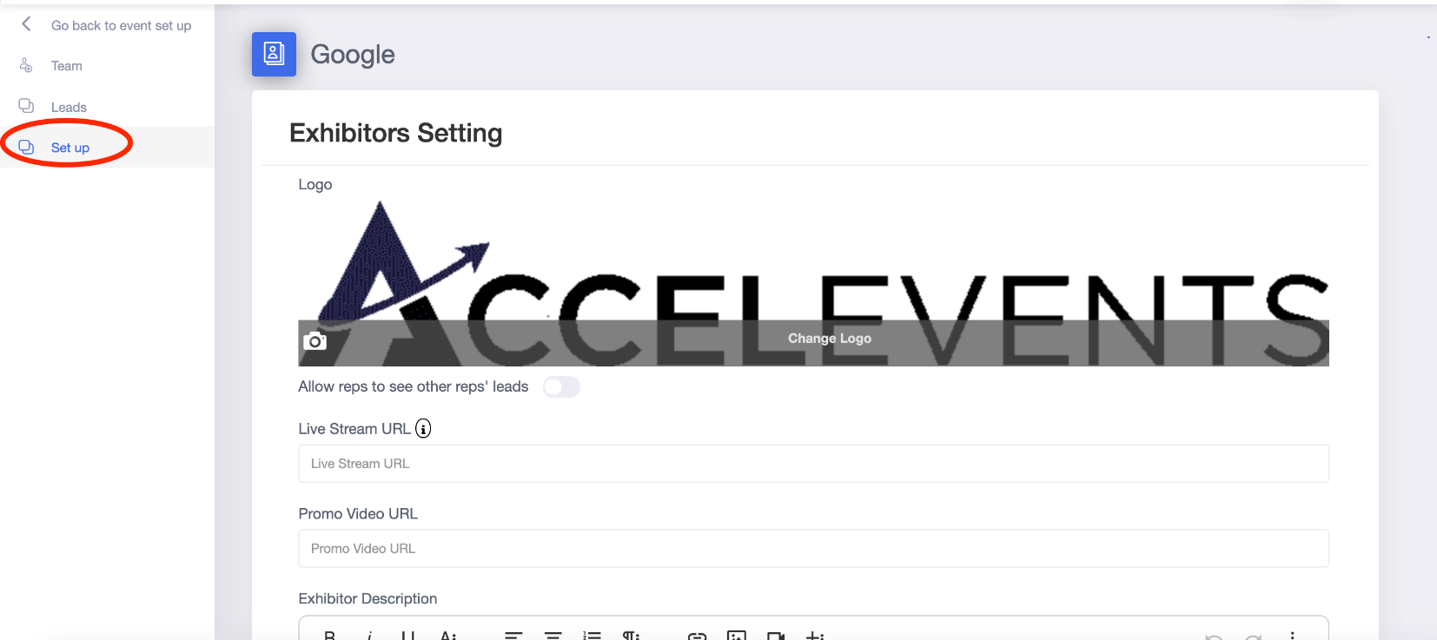

Add any of the following options to your poster presentation:

Logo: We suggest a 700x350 pixel image for optimal fit. The required file formats are PNG or JPG.
Live Stream URL: Add the link to your Zoom meeting (see further down in document for additional details on how to link your livestream video).

Promo Video URL: Share a pre-recorded video with attendees visiting your Poster Presentation. Common options are an overview of your presentation or a quick demo.

Exhibitor Description: Add a description of your Poster Presentation.

Offer & Offer Link: Leave this blank

Social Links: If you want, include links to your social media.

Documents Available to Attendees: This is the area where you can provide any resources for attendees visiting your presentation to view & download. Files here must be a PDF, DOC, DOCX, or DOCXX format. File size can be up to 10mb and up to 20 files per poster presentation.

Click “Save” to save your changes

Lead Generation (set to on but optional)
Once on your Exhibitor Portal click “Leads”
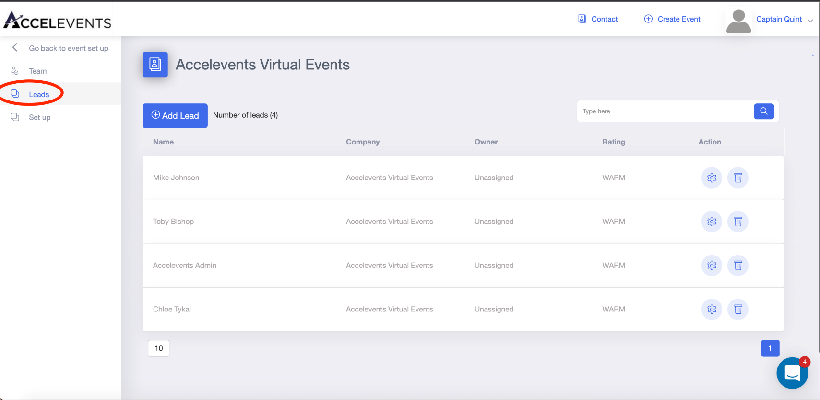
Manually add a new lead by clicking the “Add Lead” button & entering any information you gathered.
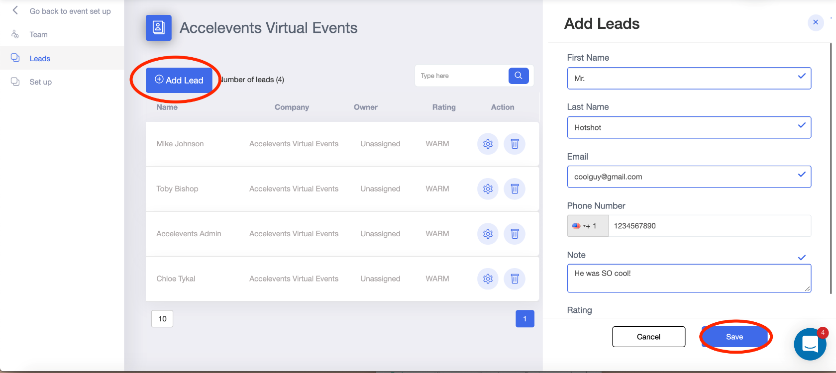
*NOTE* Leads will be automatically entered if an attendee engages with your poster by having a conversation with one of your Lead Retrievers.

Add Co-Presenters/Lead Retrievers
- Enter the Exhibitor Portal & click on the “Team” page

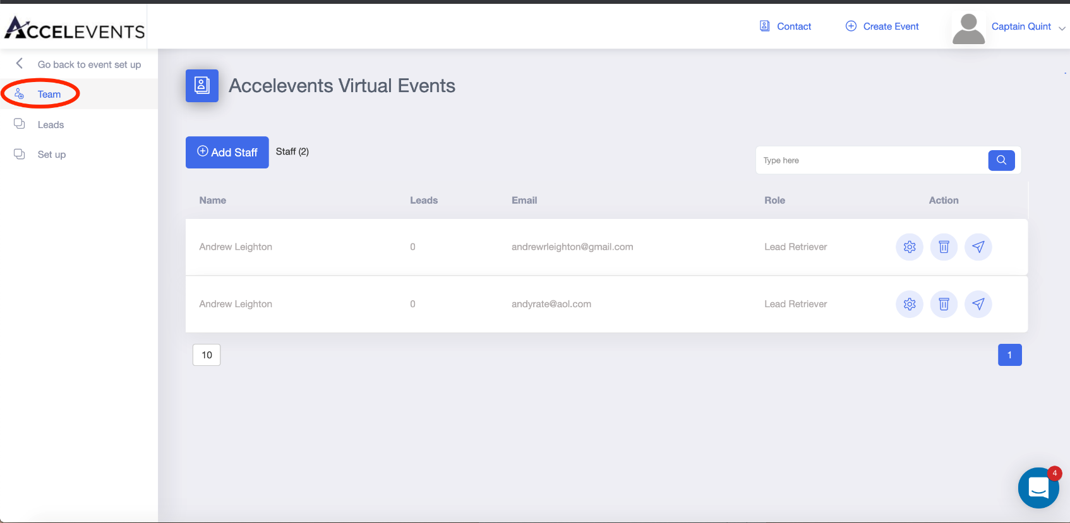

Click “Add Staff” to add a new member to your Poster Presentation and enter your teammates information.

Exhibitor Admins: will have access to the Exhibitor Portal to set up & edit presentation details.
Lead Retrievers: act as co-presenters for the attendees and are available to live chat from within the “booth” (poster session). They will not have access to the Exhibitor Portal & will NOT be able to update/change booth details.

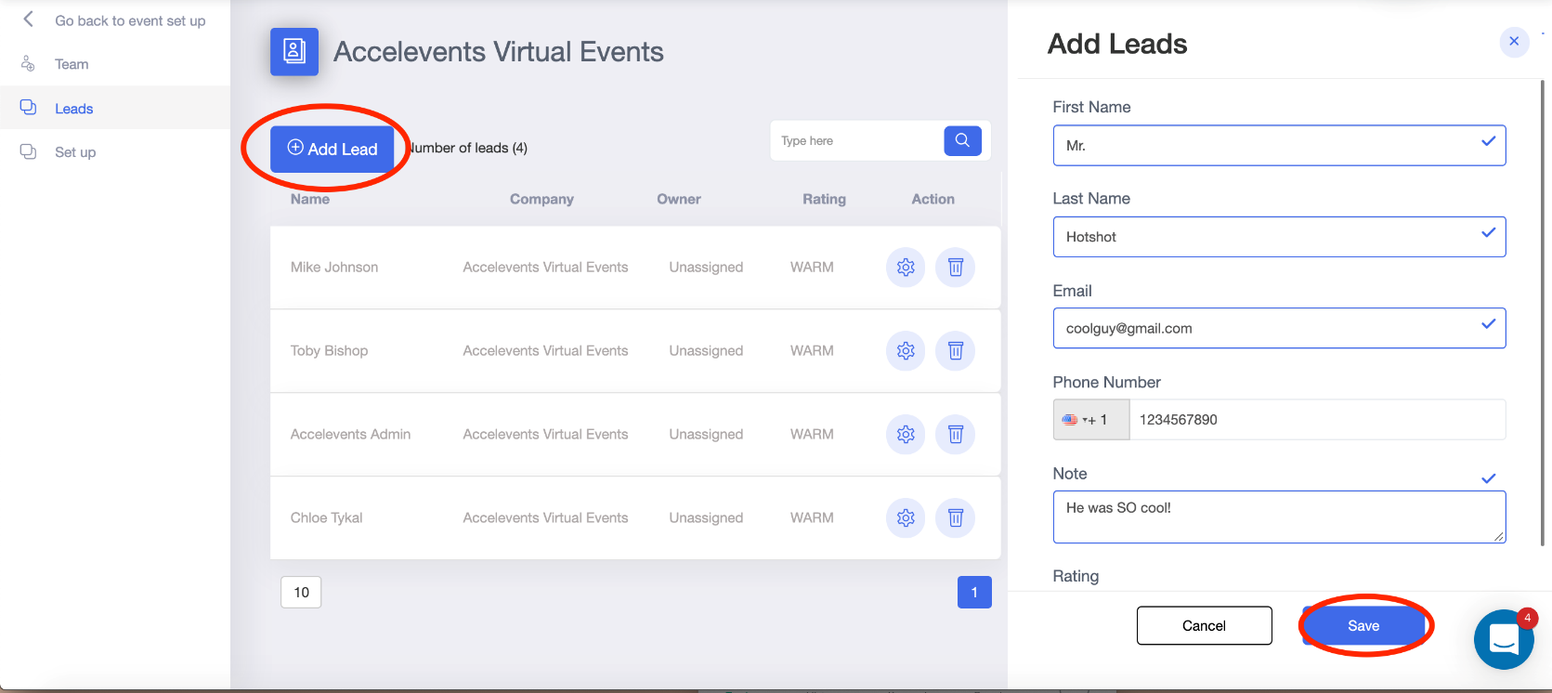
Click “Save” to finalize adding the team member. This will send them an email welcoming them to the booth's staff. Please notify your team of the Exhibit language as outlined in red at the top of this document to ease confusion.

Chat with a Lead
- Enter the virtual event hub from the event landing page.
- Click the Expo area & find your poster presentation.
- Once there, it will mark you as available.
- If an attendee sends a message to begin a conversation with you, it will appear in the right hand chat bar.

Host a Live Demo/Session
*Poster Presentations live-streaming needs to be hosted on an OUTSIDE platform (Zoom is the only live streaming platform currently supported.)
- Enter the URL to your stream on the Exhibitor Portal → Set Up page
- When ready, begin broadcasting your live session on your chosen platform.
- The stream will automatically be pushed to begin in your booth

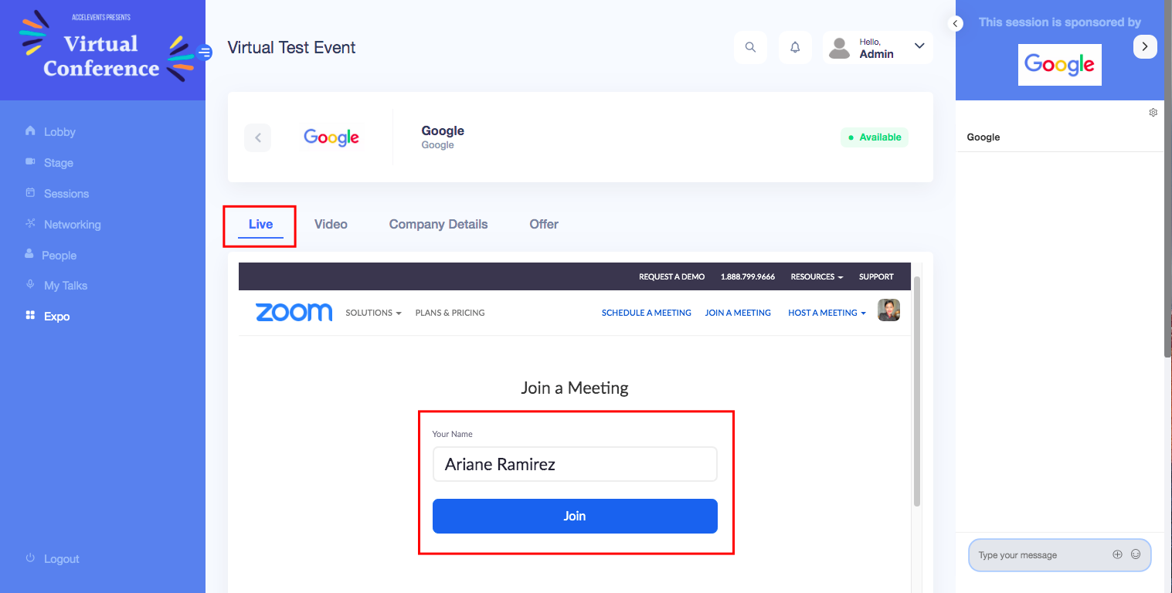

Live Stream Set Up
- Once in the Exhibitor Portal, click on the Set Up tab
- Add your Zoom meeting link to the Live Stream URL field
- Make sure to provide your Zoom password to your attendees, you can add that to your description area or provide it through the chat area in the virtual event hub
- Start your Zoom meeting through your Zoom app. Your Zoom stream will automatically begin in your booth.
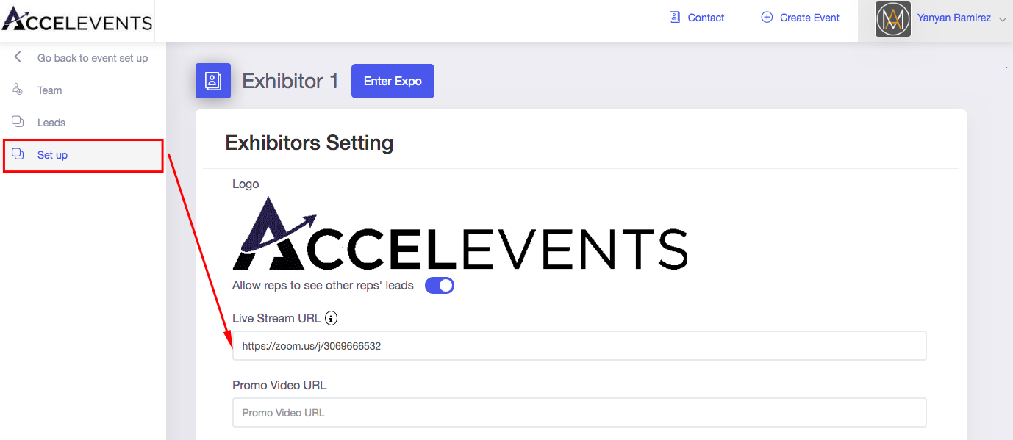

Enter the “Expo”/ Poster Area
- To see how your Poster Presentation would look like, click Enter Expo
- Click the right arrow on your Poster to enter your presentation
- On the live tab, you should see the option for attendees to join your Zoom meeting
- Attendees will need to enter their name and click Join
- On your end, you should see a request to join the meeting from your Zoom app. Click that to add the attendee to your meeting

