Speaker: How to use the virtual platform

I'm presenting a Pre-Conference Workshop, what do I do?
Once you have been added to a session as a speaker (by NEAFCS staff), check your inbox for an email inviting you to join the event (from Accelevents). From that email, click the attached link to head over to the event page.

Note: Chrome is the preferred browser to access the event page, virtual event hub and backstage studio link.

How do speakers access the studio? Watch this video here for tips - https://support.accelevents.com/en/articles/3978922-how-do-my-speakers-access-the-studio

If this is your first event or session with Accelevents, create a password to protect your account. After your password has been created, you will be able to access the Virtual Event Portal.

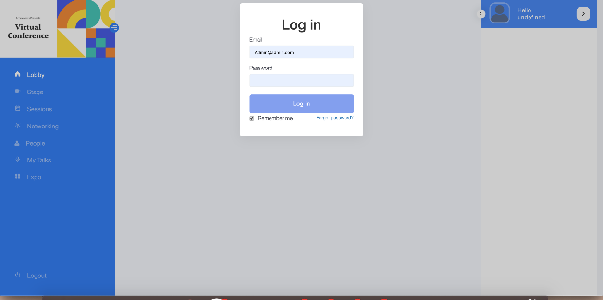

Click “My Talks” in the left hand navigation menu to access the backstage portion of the event.

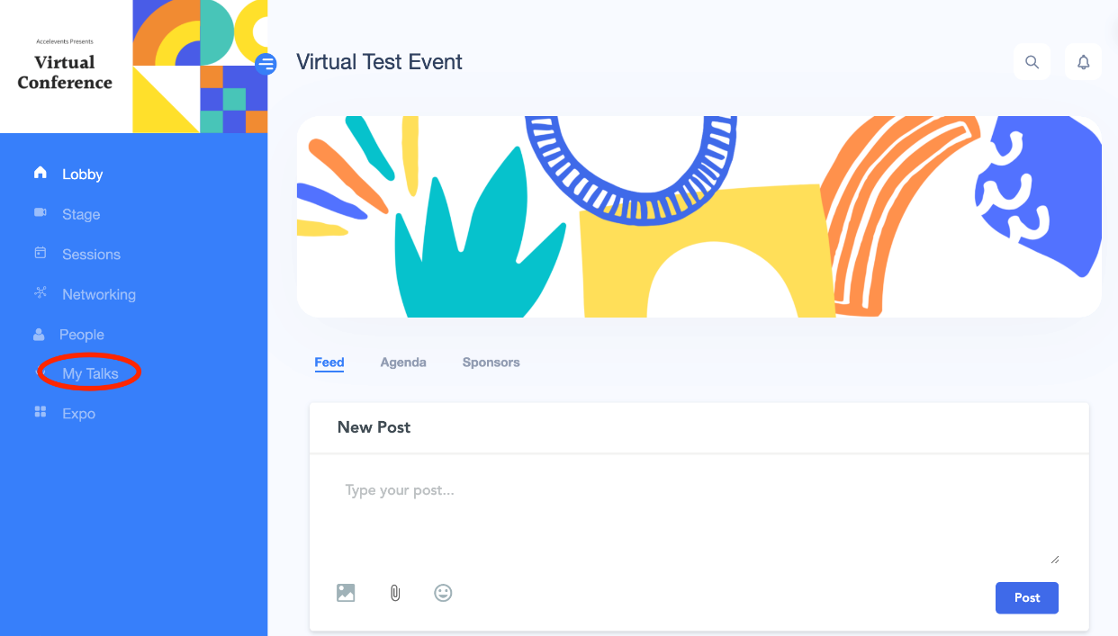
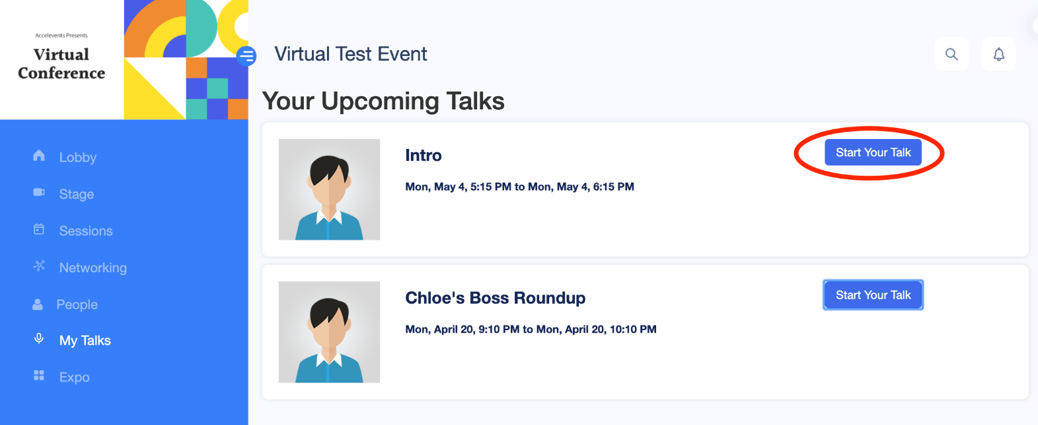

Before beginning the broadcast of the session, you can adjust your audio & video settings or upload any materials/media by clicking the “Share” icon.

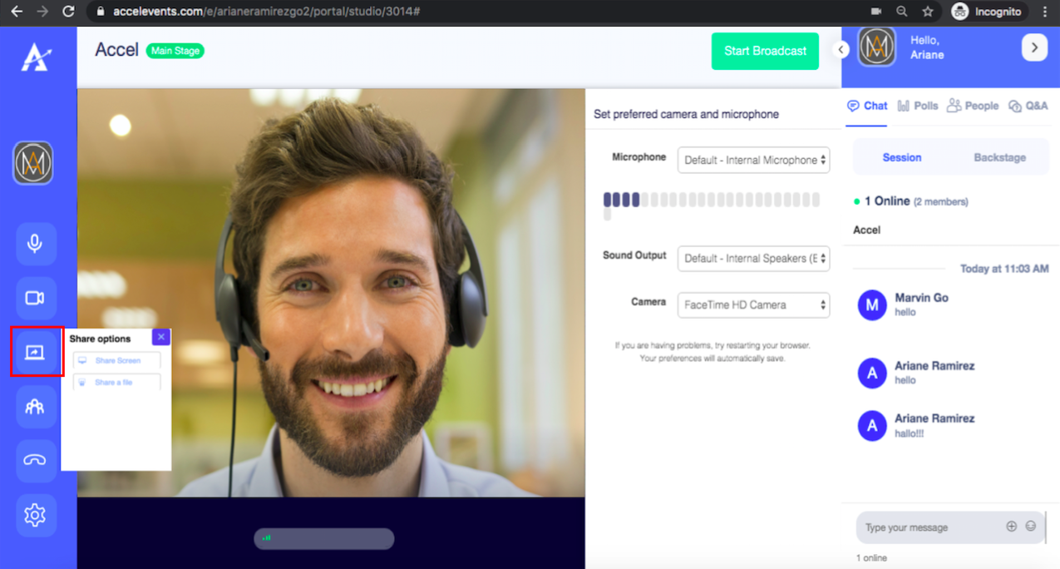

Make sure that your browser allows camera and microphone access and check the volume and camera output settings of your Accelevents Studio.

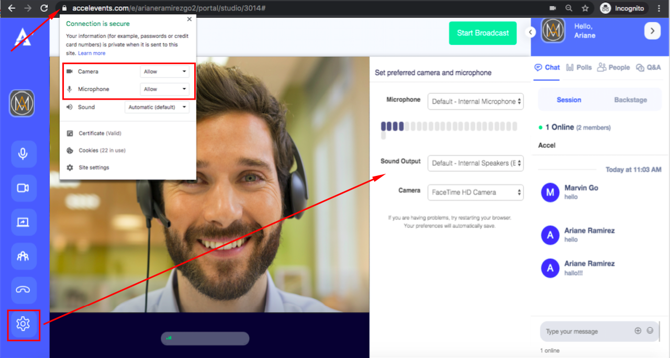

When you are ready to go live, click “Start Broadcast”

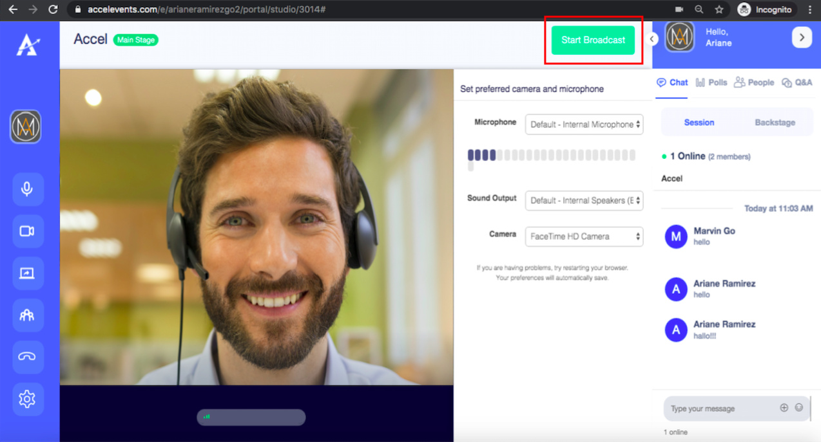

Inside The Studio
The studio has 3 parts:
- Left side panel menu
- Live video feed
- Live chat feed

The left side panel menu gives you control on the video and audio output, as well as other components to improve your presentation:
- Microphone - allows you to mute / unmute
- Webcam - allows you to turn off / on your camera
- Screen share - allows you to share your entire screen, a window, a tab from your browser or a .pdf file to present.
- Attendees - shows a list of the attendees that are watching your live broadcast
- Phone - allows you to end the broadcast
- Settings - allows you to select which camera and microphone to use and test the microphone volume

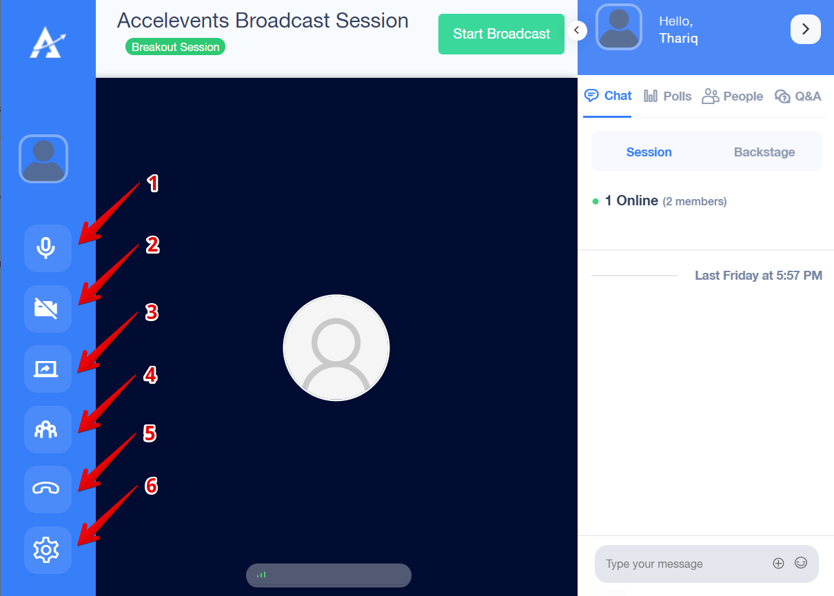
Once you access the Studio, your microphone and camera should be automatically turned on and you should be able to see your webcam image. It doesn’t mean you’re already broadcasting, though! To start broadcasting for your session, it’s necessary to click on Start Broadcast to start your live streaming. You should see a brief loading bar after that and, after the loading is finished, your broadcast should finally begin.

Camera and Microphone
Before broadcasting, you need to check if your camera and microphone is working:
- Make sure that your browser allows camera and microphone access by clicking the lock icon beside the Studio link URL
- Make sure that your Accelevents Studio camera and microphone is enabled through the left side panel
- Make sure to check the volume and camera output settings of your Accelevents Studio by clicking the settings (gear icon) on the left side panel

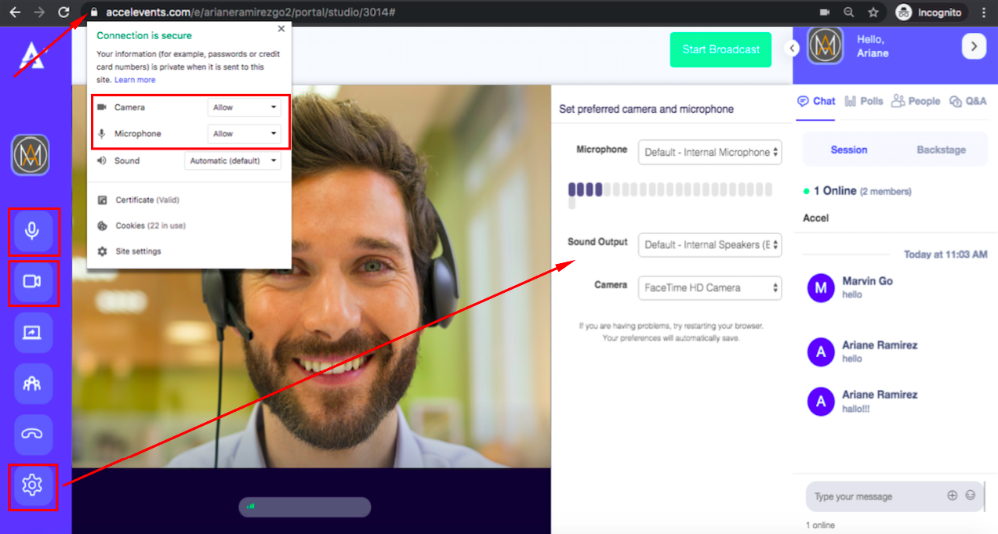
The live video feed area is where you'll see yourself on camera as well as your presentation if you're sharing your screen. On top of it is the Start Broadcast button, which you'll need to click when you're ready to start your session.
- Whoever clicks the Start Broadcast button must stay in the Studio for the duration of the session. If that person leaves the Studio then the broadcast will end.
- If someone clicks the Stop Broadcast button, even if that speaker is not the one who started the broadcast, the broadcast will stop.
- If someone has already clicked the Start Broadcast button, and another speaker accesses the studio link, the button will say Stop Broadcast for the new speaker since the broadcast has already started.
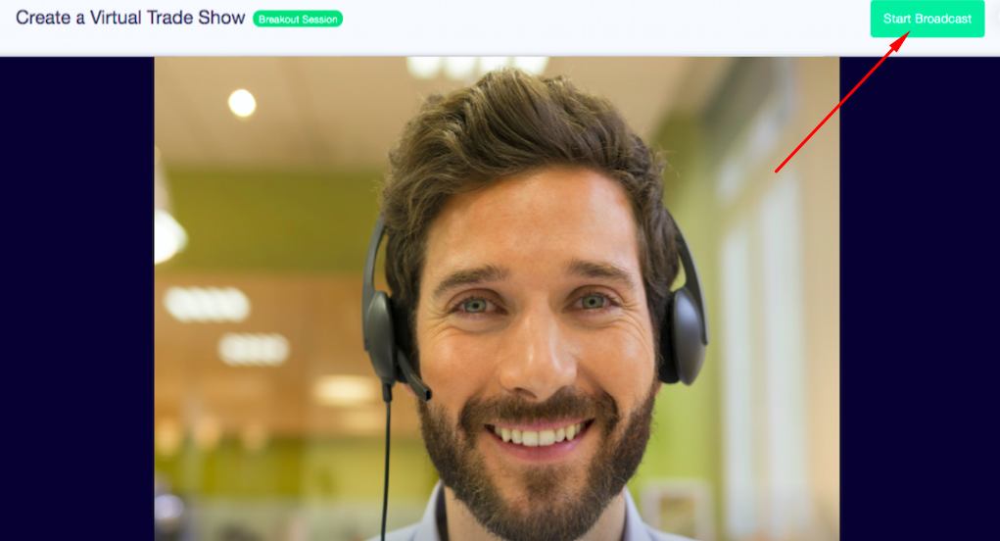

The live chat feed area is where you can type in your messages:
- Session chat: messages can be viewed by all attendees and speakers in the session
- Backstage chat: messages can be viewed only by those who have access to the backstage link including speakers and admins
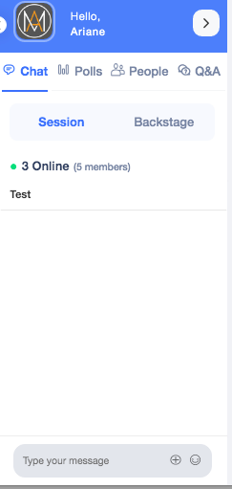
Multiple Speakers
The Accelevents Studio can have up to 16 speakers at the same time. You can choose to have 2 layouts:
- All presenters are tiled equally
- One presenter is on the center and the others are on top. If there's only 2 presenters, your video will be on top and the other presenter will be on the center.
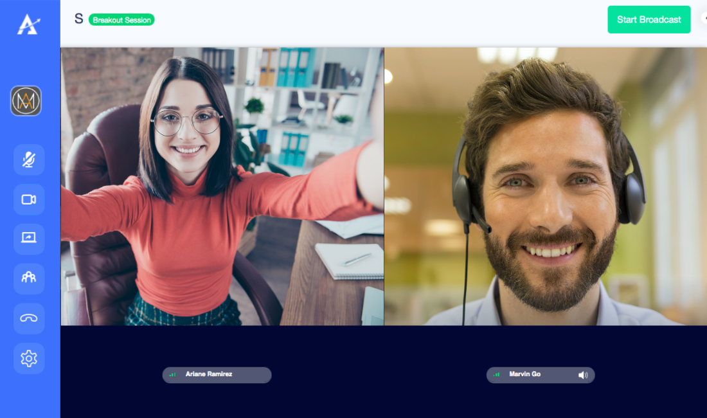

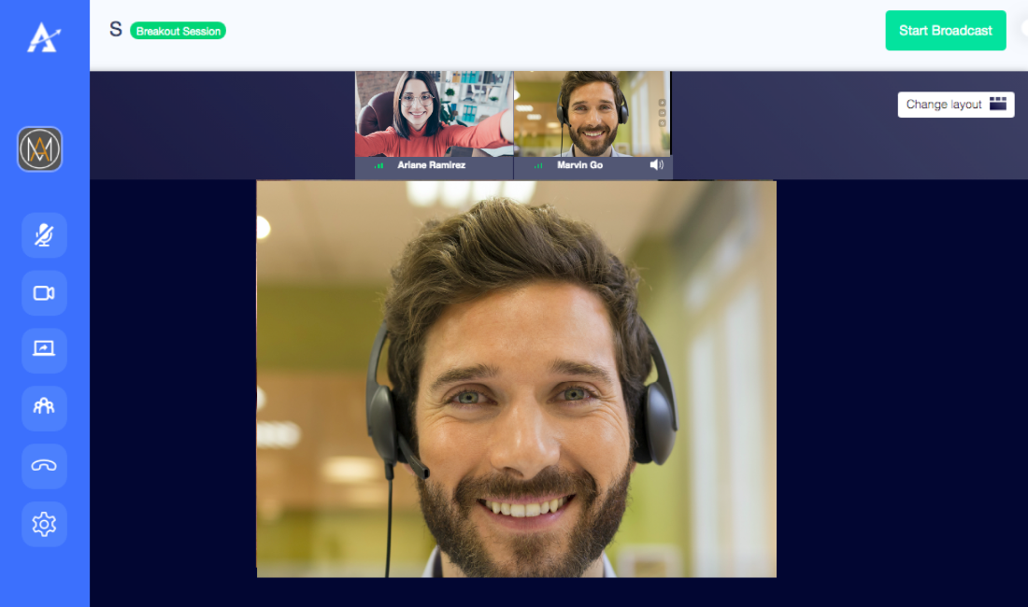
Screen Sharing
- If you're sharing your screen, the screen will be shown in the center and the speakers will be on top.
- if you're sharing your screen, no one else can share their screen. You need to stop sharing by clicking the screen share button again so that someone else can start sharing
- If you're sharing your screen, the presentation will be gray'd out on your studio, but the other presenters and attendees will see it clearly.
- If you're speaking and presenting at the same time, we recommend having 2 screens or have a moderator to be able to monitor chats and click to the next slide of your presentation without any hassle.

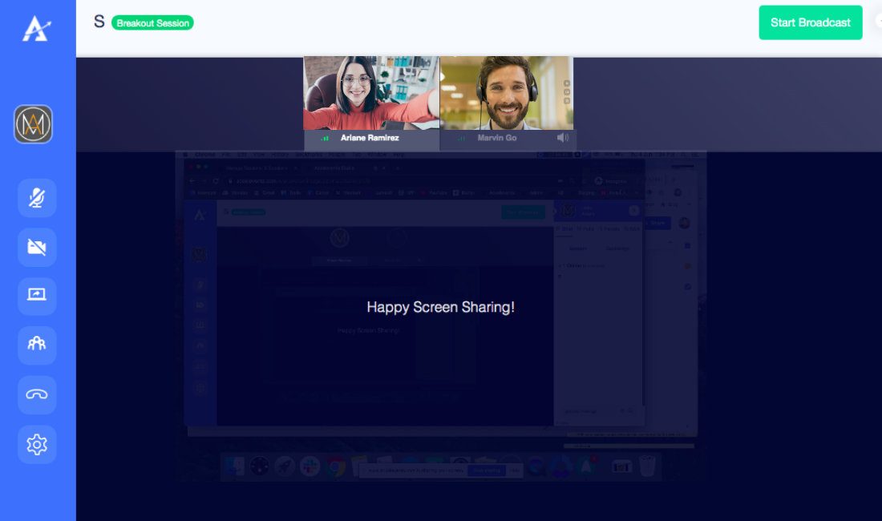
End the Broadcast
- To end the broadcast you can click the Stop Broadcast button on top or the phone icon on the left side.
- Your session is automatically recorded when you start your broadcast and will be available for download as soon as the session time is over. If you broadcasted only for 30 minutes, but your session is scheduled for 1 hour, the downloadable file should be ready at the end of that hour.

