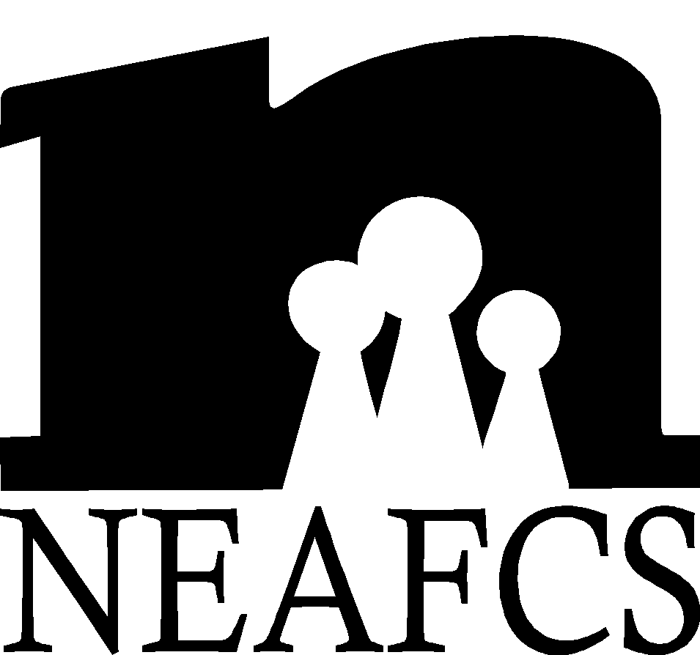 | Candidate Application for National Office
What you can expect when applying for a National Board Position:
- Newly elected individuals will receive training from board members, and materials related to the position will be passed down.
- Candidates will be invited to join the Pre-National Board Meeting as an observer to become familiar with board business (will not be reimbursed by National to attend)
- Newly elected Executive Board members may be reimbursed for one night’s lodging for post board meeting (at a rate of ½ of double room) but are not reimbursed for additional travel costs. Meal reimbursement for day of post board meeting will follow Policy Manual and current approved budget.

Upon applying for the position, I acknowledge that I will have the necessary resources (i.e. computer, internet, etc.) to complete the duties of the position.  I agree

Office Applied for: Date:
This form should be used as a guideline. When typing your own form, add more space as necessary.
First Name |  | Middle Name |  | Last Name
Job Title |  |  | Employer
Work Mailing Address |  |  | City |  |  | State/Territory | Zip
Work Email Address |  |  | Home Email Address
Work Phone/Extension | Work Fax |  |  |  | Home Phone

I. Education Background
BS/BA
Major Institution Year
MS/MA
Major Institution Year
PhD
Major Institution Year

II. State/Territory Affiliate Experience
Office Year(s)

Committee Chair Year(s)

Committee Year(s)

III. NEAFCS Experience

Office Year(s)

Committee Chair Year(s)

Other Assignments Representing NEAFCS Year(s)

Annual Sessions Attended (list years)

Submissions for Awards, Webinars and/or Annual Session Proposals (concurrent session, poster, ignite)
Submission did not have to be accepted.
Check all that apply:
□ Webinar Submission Year(s):
□ Annual Session Proposal Year(s): Proposal Type:
□ Award Submission Year(s):

IV. Non-Association Extension Leadership Assignments
(Annual conference committees, search committees, etc.)
Assignments: Elected (E) or Appointed (A) Year(s)

V. Membership/Leadership in Other Organizations
(Professional, civic, service, religious or agency related organizations)
Organizations, Leadership role Year(s)

VI. Work Experience Other Than Extension (if applicable)
Positions Year(s)

VII. Awards and Honors
Awards Date(s)

Position Statement
A. Why would you like to be a candidate for this office?

B. If you were elected, what would be your top priority/goal for your term?

Are you willing to be considered as a candidate for a different office? The national nominating committee chair would contact you first as to your preference and willingness to serve in any other position. Yes  No  Maybe 
Are you willing to leave your application on file for three (3) years in the event of a position vacancy or for reconsideration for office for the next election? Yes  No 
Your signature below confirms that you have read the current NEAFCS Policy Manual and agree to the duties and qualifications for the position in which you are applying for as well as additional policies outlined in the Manual.

________________________________________ ________________________________________
Signature of Applicant Date
Letters of support and recommendation from the following individuals must accompany the application.
- State Director of Extension (required)
- State Program Leader or immediate supervisor (one required)
- NEAFCS board member or state/territory affiliate president (optional)

Applications are due to the National Nominating Committee Chair by May 1st. Please include with your application a high resolution headshot photo for the candidate display at Annual Session.

NEAFCS is an equal opportunity/affirmative action association. NEAFCS values and seeks a diverse membership. There shall be no barriers to full participation in this organization on the basis of race, color, gender, age, religion, national origin, disability, veteran status, or sexual orientation. Membership is not by invitation. (Strategic Plan 1993-97)

