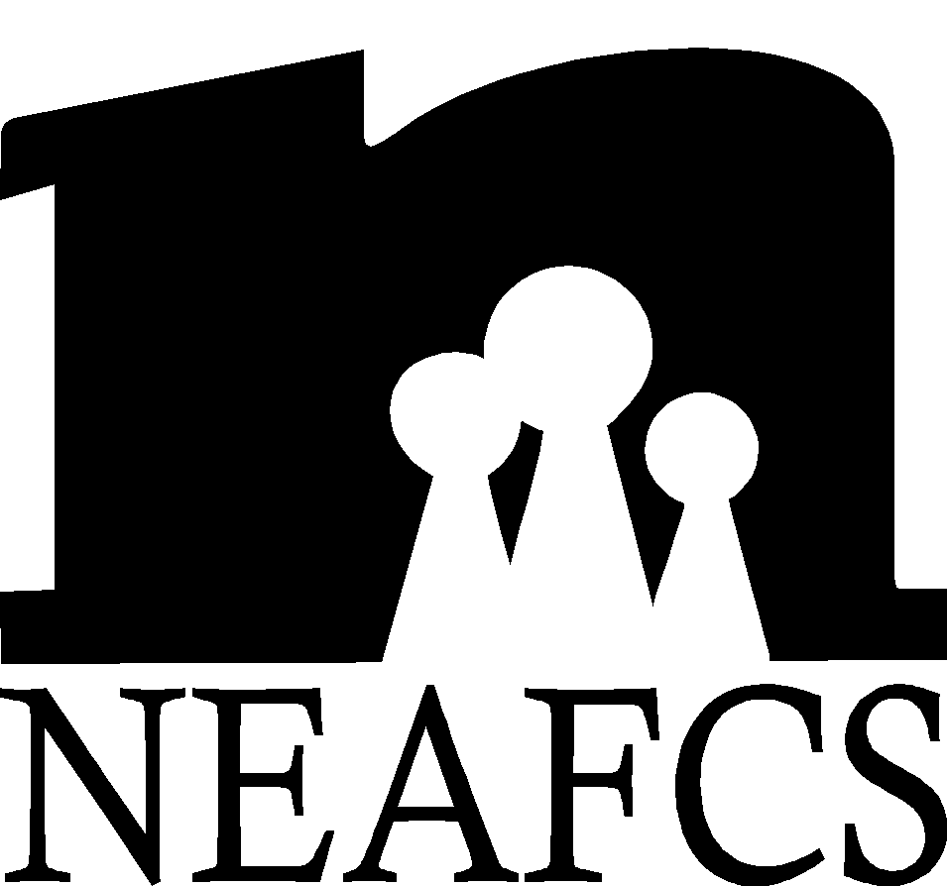 | Candidate Application for National Office

Office Applied for: Date:
This form should be used as a guideline. When typing your own form, add more space as necessary.
First Name |  | Middle Name |  | Last Name
Job Title |  |  | Employer
Work Mailing Address |  |  | City |  |  | State/Territory | Zip
Work Email Address |  |  | Home Email Address
Work Phone/Extension | Work Fax |  |  |  | Home Phone

I. Education Background
BS/BA
Major Institution Year
MS/MA
Major Institution Year
PhD
Major Institution Year
II. NEAFCS Experience

Office Year

Committee Chair Year

Other Assignments representing NEAFCS Year

Annual Sessions Attended (list years)

III. State/Territory Affiliate Experience
Office Year

Committee Chair Year

Committee Year

IV. Non-Association Extension Leadership Assignments
(Annual conference committees, search committees, etc.)
Assignments: Elected (E) or Appointed (A) Year

V. Membership/Leadership in Other Organizations
(Professional, civic, service, religious or agency related organizations)
Organizations, Leadership role Year

VI. Work Experience Other Than Extension
Positions Years

VII. Awards and Honors
Awards Date

Position Statement
A. Why would you like to be a candidate for this office?

B. If you were elected, what would be your top priority/goal for your term?

Are you willing to be considered as a candidate for a different office? The national nominating committee chair would contact you first as to your preference and willingness to serve in any other position. Yes  No  Maybe 

Are you willing to leave your application on file for three (3) years in the event of a position vacancy or for reconsideration for office for the next election? Yes  No 

________________________________________
Signature of Applicant

________________________________________
Date
Letters of support and recommendation from the following individuals must accompany the application.
- State Director of Extension (required)
- State Program Leader or immediate supervisor (one required)
- NEAFCS board member or state/territory affiliate president (optional)

Applications are due is April 1. Please include with your application an 8 x10 or pdf
headshot photo for the candidate display at annual session.

