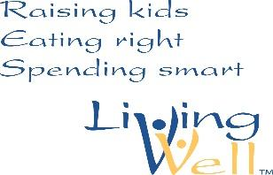
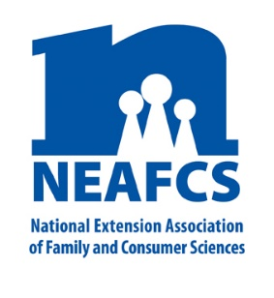
Living Well Month March 2020
A public service campaign to promote programs developed and managed by Extension FCS educators

Social Media Post Ideas
Hashtags to include: #Minnesota, #ItStartsWithUs, #LivingWellMonth

Whether you are trying to stretch your food dollar through meal planning, make decisions about financial planning, or get tips on starting a home-based food business, Extension has research-based answers. Learn more @UMNExt https://extension.umn.edu/ @NEAFCS #LivingWellMonth  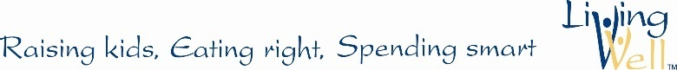 | @UMNExt SNAP-Ed Educators provide colorful tastings to 3rd-5th graders. Go Wild with Fruits & Veggies! newsletters and challenge forms involves the whole family. Paper chains in classrooms track and encourage healthy choices. Students increased their daily fruit intake by 1/3 cup. Learn more https://z.umn.edu/SNAPEDforKids #LivingWellMonth @NEAFCS
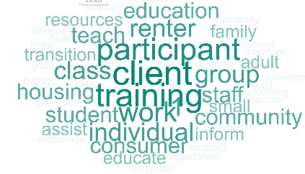  Being a successful renter means understanding how to secure housing, care for your unit and maintain good communication. @UMNExt has resources for you! The RentWise curriculum helps agency staff teach others https://z.umn.edu/RenterEd @NEAFCS #LivingWellMonth | 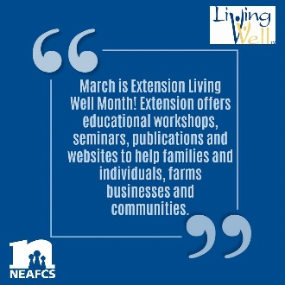  @UMNExt Family & Consumer Science Extension Educators offer education and resources to help families and communities achieve a positive healthy lifestyle to live well. Learn more: https://z.umn.edu/livewell #LivingWellMonth @NEAFCS
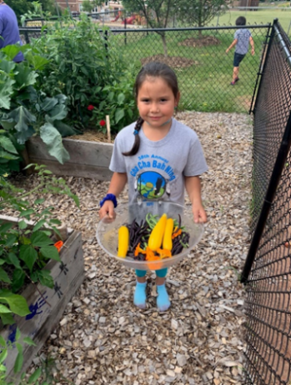  Children build connections between growing and eating fresh fruit and veggies through hands-on gardening, science and nutrition education @UMNExt Children’s Garden in Residence Summer Program. It reached 588 children across 17 #Minnesota counties in 2019. https://z.umn.edu/GardeningForKids @NEAFCS #LivingWellMonth  Photo source: Anna Sneltjes. Permission release form on file. | 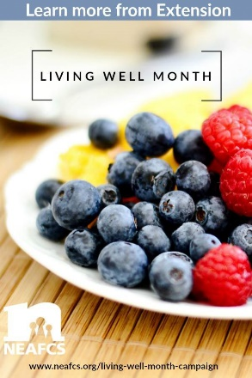  @UMNExt SNAP-Ed encourages families to stretch their food dollars by preparing meals from scratch. Eat at home to increase fruit and vegetable intake, avoid over-sized portions and control added salt, sugar and fats. Learn more @UMNExt https://z.umn.edu/SNAPEDforFamilies @NEAFCS #LivingWellMonth
Once you have determined your needs and wants, it’s time to set goals. Setting goals is an effective way to get the things you want out of life. Want to learn how to create smart goals? Watch @UMNExt video https://z.umn.edu/SMARTplan @NEAFCS #LivingWellMonth | What are you doing this month to ‘live well’? Share your photos and tweets with @UMNExt and @NEAFCS using the hashtag #LivingWellMonth
Once you have set financial goals, begin to gather information about your current money management practices. It’s important to know where your money is currently going. To learn more information about your spending patterns, keep a spending log or spending tracker. Watch this @UMNExt video to learn more: https://z.umn.edu/spendingtracker @NEAFCS #LivingWellMonth  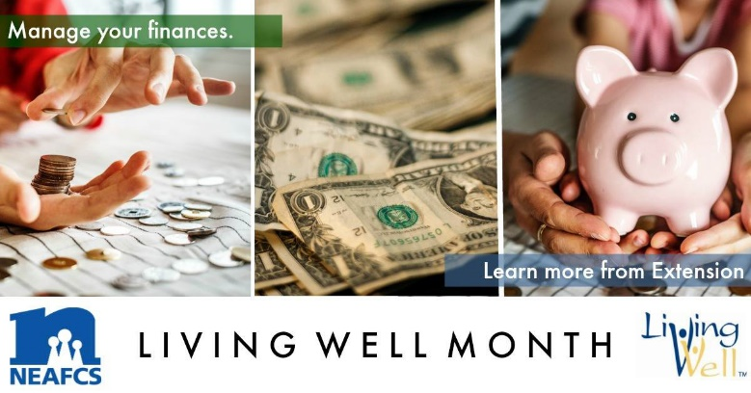 | Want to create excitement and buzz around #Minnesota #FarmersMarkets? The @UMNExt Power of Produce (PoP) Club provides children with $2 tokens to spend on fresh produce. Access the free toolkit @UMNExt https://z.umn.edu/markets @NEAFCS #LivingWellMonth  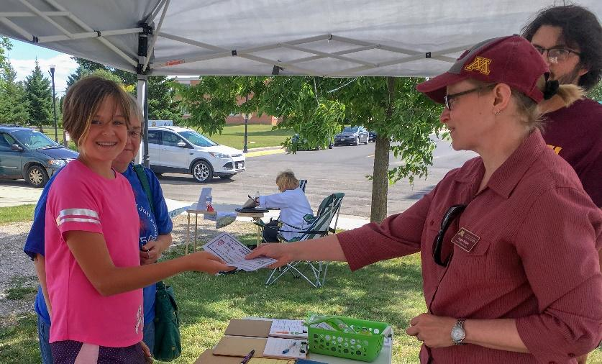  Photo source: Megan Hruby. Permission release form on file.
What goals do you have for #LivingWell? Check out @UMNExt goal-setting worksheet to map out how to adapt and maintain healthy behaviors https://z.umn.edu/setgoals @NEAFCS | 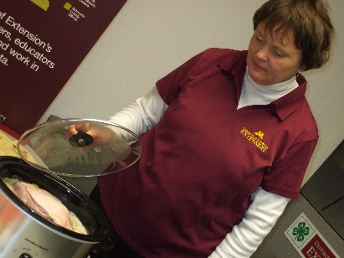  Keep meals simple. Slow cookers save time in the evening! See @UMNExt #foodsafety tips https://z.umn.edu/slowcooker @NEAFCS #LivingWellMonth  Photo source: Suzanne Driessen. Permission granted.
Educators from @UMNExt Family Resiliency team put together a series of webinars, conferences, and workshops educating over 1,000 consumers and professionals on Financial Preparedness for Disasters. For resources on disaster preparedness visit https://z.umn.edu/disasterpreparation @NEAFCS #LivingWellMonth | 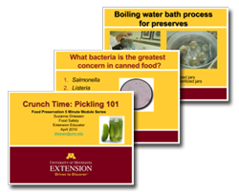  Want to #preserve the #food you buy or grow? @UMNExt #foodsafety educators produced videos to get you started. View here: https://z.umn.edu/5bpi @NEAFCS#LivingWellMonth
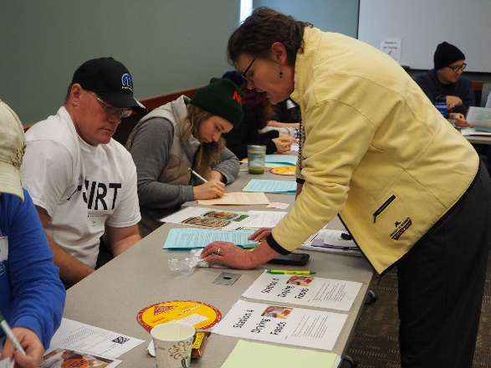  @UMNExt Food Safety educators educate Minnesota cottage food producers through the Cottage Food: Keep it Safe! Keep it Legal! program to reduce foodborne illness and food allergic reactions. Learn more about the online or in-person course at https://z.umn.edu/cfproducers @NEAFCS #LivingWellMonth  Photo source: Suzanne Driessen. Permission granted. | 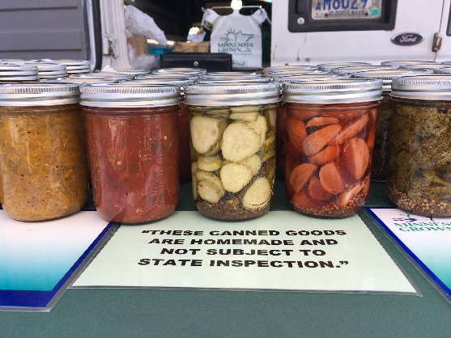  Ever wonder what it would take to sell some of your delicious home-made snacks that your family and friends love so much? Check out the requirements https://z.umn.edu/CFPregs and @UMNExt #foodsafety course at https://z.umn.edu/CFPfoodsafety @NEAFCS #LivingWellMonth  Photo source: Suzanne Driessen. Permission granted.
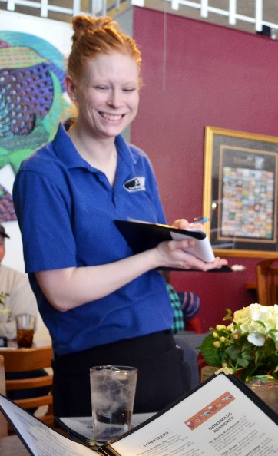  #Minnesota Certified Food Protection Managers can earn continuing education credit through @UMNExt #foodsafety online course, Serve It Up Safely. Learn more at https://z.umn.edu/serve @NEAFCS #LivingWellMonth  Photo source: UMN Ext Image Gallery | Family meals are a simple, healthy way to enjoy screen-free time as a family. See tips and ideas for dining with teens @UMNExt https://z.umn.edu/familymeals @NEAFCS #LivingWellMonth #NationalNutritionMonth  Photo source: UMN Ext Image Gallery
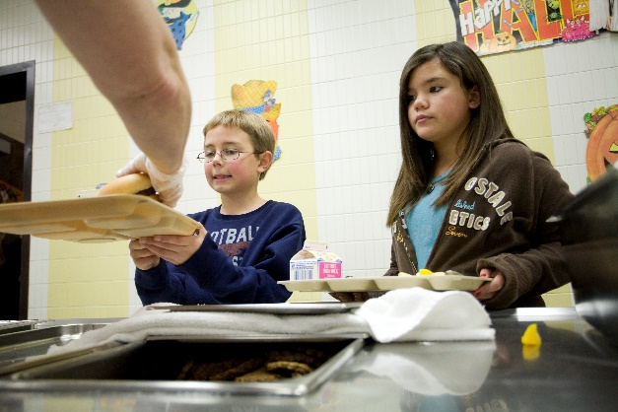  @UMNExt Certified Technical Assistance Providers are making the healthy choice the easy choice for students across #Minnesota through the Smarter Lunchrooms program. Contact your local Health and Nutrition Educator to make healthy changes to your school’s lunchroom environment! https://z.umn.edu/smarterlunchrooms @NEAFCS #LivingWellMonth  Photo source: UMN Ext Image  Gallery  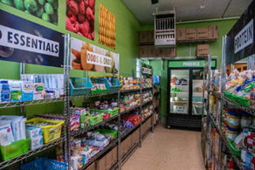  Providing healthier food options with dignity and respect at food shelves is a priority for @UMNEXt nutrition educators, Kelly Kunkel (Mankato) and Anna Sneltjes (St. Cloud). Through training, technical support and changing the food environment, food shelves in 27 counties across Minnesota serve their clients in new and innovative ways. https://z.umn.edu/HlthyFoodShelves @NEAFCS #LivingWellMonth  Photo source: Kelly Kunkel. | Are you a parent who is concerned about giving "too much" to your children? Are you interested in finding out how overindulgence affects families? Then the Parenting in the Age of Overindulgence online course is for you! Learn more @UMNExt https://z.umn.edu/ParentingTooMuch  @NEAFCS #LivingWellMonth  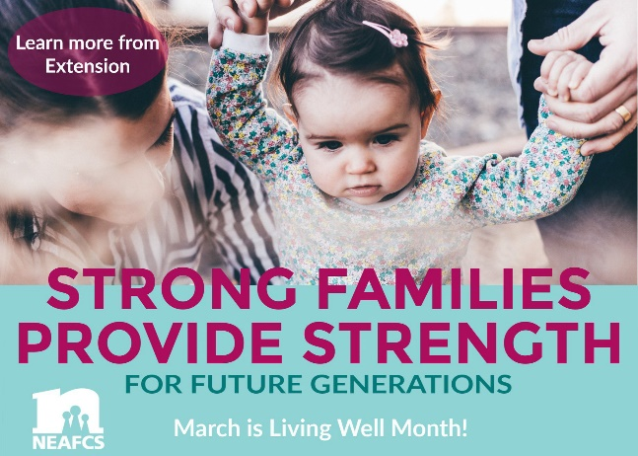  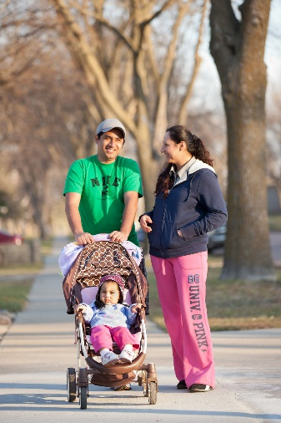  Part of #LivingWell includes being physically active! Check out @UMNExt tip sheet for how much and what types of physical activity are important for a healthy lifestyle https://z.umn.edu/howmuchPA @NEAFCS  Photo source: UMN Ext Image Gallery
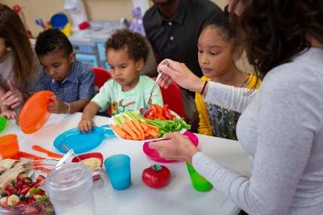  Head Start parents and children consume more fruits and vegetables and are more physically active thanks to a new Minnesota SNAP-Ed curriculum, My Time to Eat Healthy & Move More. If you’re a home visitor, look into getting trained today! https://z.umn.edu/mytimeMN #LivingWellMonth @NEAFCS  Photo source: UMN Ext Image Gallery | 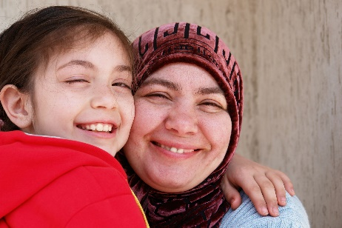  Are you concerned about giving "too much" to the children in your care? Do you want to know how overindulgence affects all types of families? Do you want practical and easy parenting tools that you can use right away? Then the Parenting with a Good Heart Online Course is for you! Learn more @UMNExt https://z.umn.edu/ParentingForGood @NEAFCS #LivingWellMonth  Photo source: UMN Ext Image Gallery
Feeling stressed? Try out some of @UMNExt stress relief tips during #LivingWellMonth https://z.umn.edu/relief  @NEAFCS  Photo source: UMN Ext Image Gallery | A spending plan or budget helps keep your spending and savings practices in line with your money management plan. It helps you know how much money you have coming in and what is going out and to make changes if needed. Learn more about creating a spending plan at https://z.umn.edu/SpendingPlanVideo @NEAFCS #LivingWellMonth  Photo source: UMN Ext Image Gallery
Do you spend a lot of time sitting in the car or sitting at a desk? Practice some of these simple exercises during #LivingWellMonth to keep your body lose during long days @UMNExt https://z.umn.edu/sittingactivities | @UMNExt Start Strong: Cooking, Feeding, and More helps #Minnesota child care provider to create healthy food environments for children. After the training, child care providers indicate greater confidence and ability to prepare healthy food for the 400 children they serve. https://z.umn.edu/HlthyFoodEnv @NEAFCS #LivingWellMonth
@UMN Extension offers educational workshops, seminars, publications and websites to help families and individuals, farms businesses and communities to live well. https://extension.umn.edu/ @NEAFCS #LivingWellMonth | Military service professionals are nurturing resilience in military children and parents thanks to webinars co-facilitated by @UMNExt educators through the national Military Families Learning Network (MFLN). Learn about upcoming webinars at: https://z.umn.edu/militarytransitions @NEAFCS #LivingWellMonth

