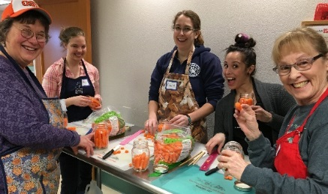

Extension helps keep home-preserved food safe
With the resurgence of interest in “eating local,” many people are acquiring food from their farmers’ markets, or growing it themselves, and preserving it at home. Commercial food processors must follow strict government regulations for handling and preserving food. No such rules exist for people who home-can or freeze their garden produce, or meat or fish.
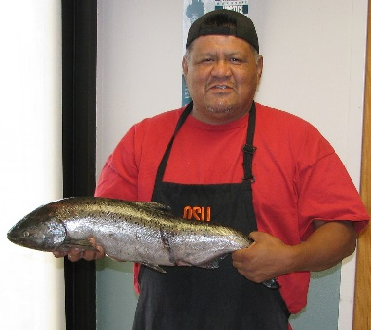
Without up-to-date information and proper equipment, home food preservers risk introducing foodborne pathogens into their foods. Food poisoning is not only potentially deadly, it’s expensive: a single case of botulism—a foodborne pathogen that can lurk in improperly home-canned foods—is estimated to cost between $1.5 and $1.9 million.
OSU Extension’s Family and Community Health program (FCH) has long provided research-based information to help people preserve food safely at home. In 2016, FCH faculty, staff and volunteers in Deschutes County conducted food safety/food preservation workshops in Redmond, Warm Springs and Fossil.
Class leaders taught the relevant research-based background information, explained the food science, and led the class in hands-on food preservation workshops. Participants took home their preserved foods along with tested recipes and important information on proper equipment.
Post-class surveys showed that participants went away with better knowledge and increased likelihood of practicing safe food-preservation techniques. More than half of the 130 survey respondents said they reviewed their own food-preservation information to see whether it was current. All respondents reported that they had changed their practices as a result of taking the workshop, and all indicated that they would recommend the class to others.
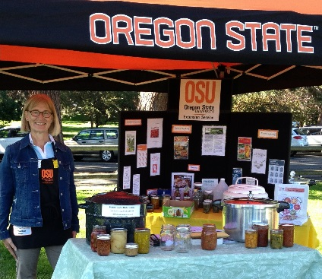
FCH also takes research-based food safety/food preservation information into the community through demonstrations and staffed displays at community events and county fairs. Pressure canner dial gauges are tested at county Extension offices, free, for accurate processing.
In our area, 20 Master Food Preserver (MFP) volunteers have been trained and supported by Glenda Hyde. Once certified with 44 hours of training and passing a comprehensive written exam, MFPs contribute volunteer hours to promote food safety/preservation to the public. In 2016, faculty, staff and volunteers reached 6115 Central Oregonians. Local MFPs contributed 1008 hours, a value of $24,333.12 ($24.14/hour¹).
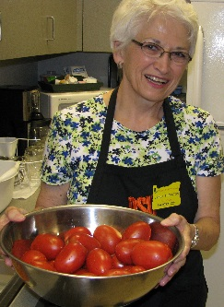
New resources, added to traditional education methods for consumers, help them find and share up-to-date, tested recipes from reliable resources “24/7.” Glenda serves as a regular administrator for the OSU Extension Food Preservation Facebook page; and responds to Ask an Expert – food safety questions, an on-line Q&A forum. She also has served as a co-instructor of a multi-state effort since 2009 with U Idaho, Preserve @ Home, a comprehensive, food preservation on-line class with a hands-on lab, winning the NEAFCS 1st Place Food Safety Award in 2016.
Other new or updated statewide efforts that benefit all Oregonians are the Food Safety/Preservation Hotline, OSU Extension food preservation publications available free, on-line; and a free canning app, the Canning Checklist and Timer.
In 2017, three OSU student interns gained experience with food safety and preservation education by assisting with local efforts.
1 http://independentsector.org/volunteer_time.html

